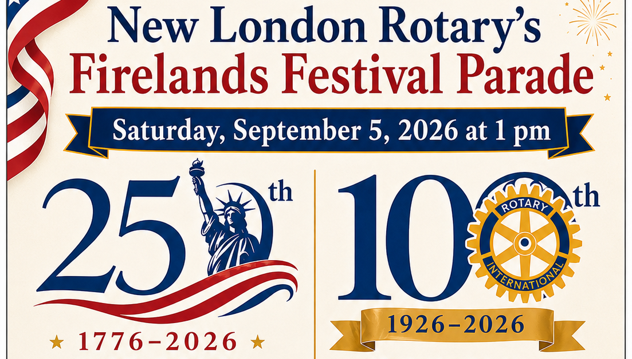
Parade Entry Form
Parade Theme: 250 years of USA Freedom, 100 years of NL Rotary Service
Marching Units – Floats – Commercial/Businesses – Horses – Demo Cars – Misc

Name/Organization ____________________________________________

Address _____________________________________________________

Contact Name ______________________ Phone ____________________
Information about your entry for parade announcer
____________________________________________________________

____________________________________________________________

____________________________________________________________

Parade contact info: Shelley Suvar 419-929-8487
Mail entry to: PO Box 43, New London, Ohio 44851 or email to: suvarauctions@gmail.com
You can pre-register with this form or register the day of the parade from Noon until 12:45 pm just east of Dollar General (look for parade signs)

